Bug Report
BUG - Application takes longer than expected to load on startup.
Module: Application Launch
Severity: Medium
Priority: High
Steps to Reproduce:
Launch the application.
Observe the application's loading time.
Expected Result:
The application should load within an acceptable time and open smoothly.
Actual Result:
The application takes longer than expected to load when launched.
Status:
Open
Screenshot:
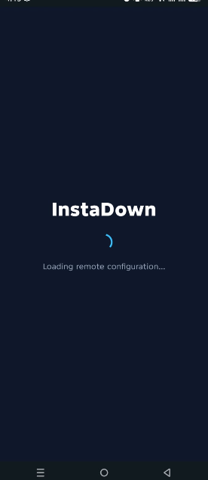

BUG-001 - Favorite status is not retained after navigation.
Module: Saved Videos
Severity: Medium
Priority: High
Steps to Reproduce:
- Open Saved Videos.
- Mark any video as favorite.
- Navigate to the Home tab.
- Return to the Saved Videos tab.
Expected Result: The selected video should remain marked as favorite.
Actual Result: The favorite status is removed after navigating back.
Status: Open
Screenshot:

BUG-002 - No dedicated section is available for favorite videos.
Module: Saved Videos
Severity: Medium
Priority: Medium
Steps to Reproduce:
- Open Saved Videos.
- Mark one or more videos as favorite.
- Look for a Favorites section or screen.
Expected Result: Favorite videos should be accessible through a dedicated Favorites section.
Actual Result: No Favorites section is available in the application.
Status: Open
Screenshot:
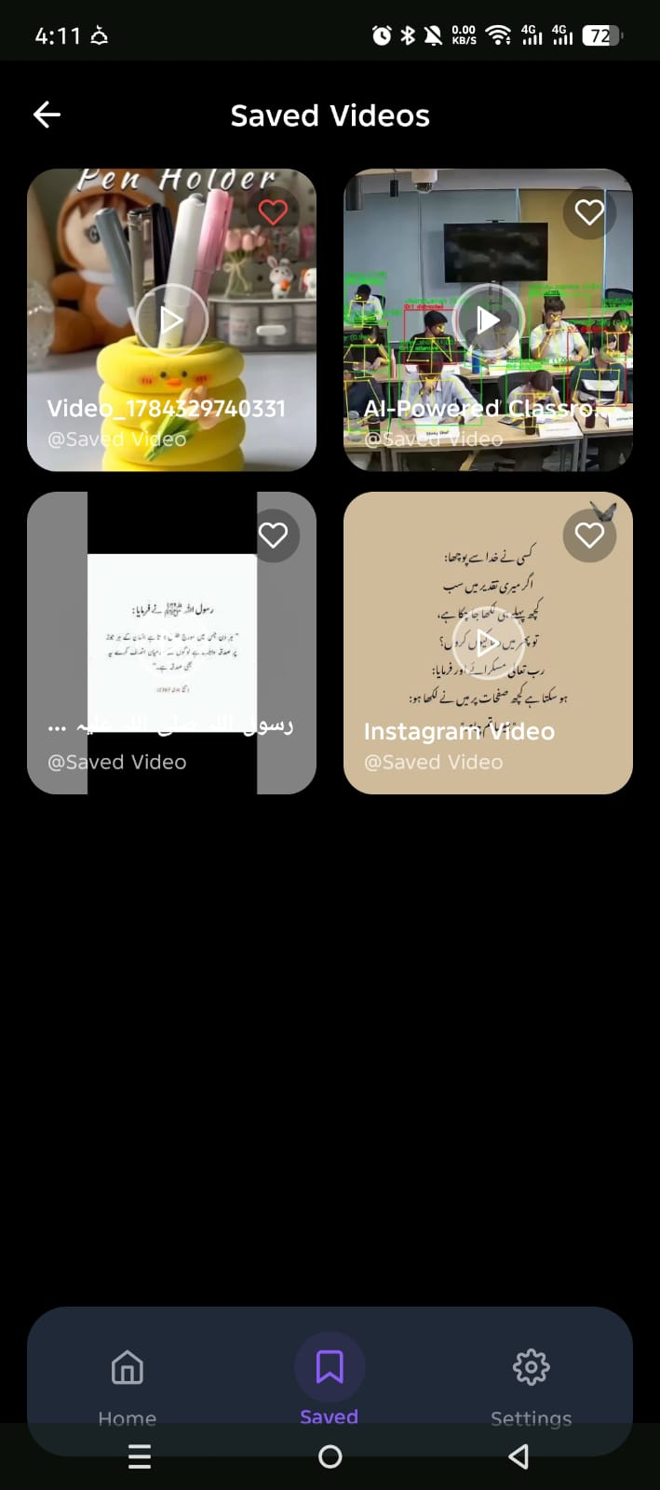

BUG-003 - Notification toggle state is not persistent after reopening the application.
Module: Settings -> Notifications
Severity: Medium
Priority: High
Steps to Reproduce:
- Enable Notifications.
- Close the application.
- Reopen the application.
Expected Result: Notifications should remain enabled.
Actual Result: Notification toggle is automatically turned OFF.
Status: Open
Screenshot:
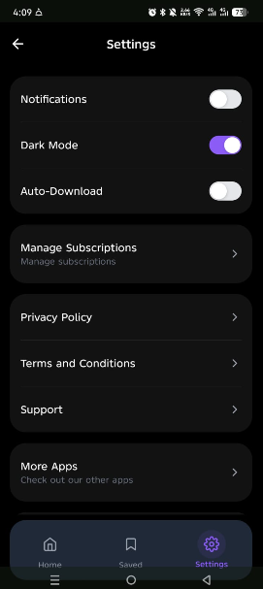

BUG-004 - Dark Mode preference is not saved after reopening the application.
Module: Settings -> Dark Mode
Severity: Medium
Priority: High
Steps to Reproduce:
- Enable Dark Mode.
- Close the application.
- Reopen the application.
Expected Result: Dark Mode should remain enabled.
Actual Result: Dark Mode is automatically disabled.
Status: Open
Screenshot


BUG-005 - Auto Download toggle state is not persistent after reopening the application.
Module: Settings -> Auto Download
Severity: Medium
Priority: High
Steps to Reproduce:
- Enable Auto Download.
- Close the application.
- Reopen the application.
Expected Result: Auto Download should remain enabled.
Actual Result: Auto Download is automatically disabled.
Status: Open
Screenshot


BUG-006 - Rewarded ad does not provide any visible reward or confirmation to the user.
Module: Watch Rewarded Ad
Severity: Medium
Priority: Medium
Steps to Reproduce:
- Open Settings.
- Tap Watch Rewarded Ad.
- Watch the rewarded ad completely.
Expected Result: The application should clearly indicate the reward granted to the user and display or apply it accordingly.
Actual Result: The rewarded ad plays successfully, but no reward or confirmation is displayed.
Status: Open
Screenshot:
